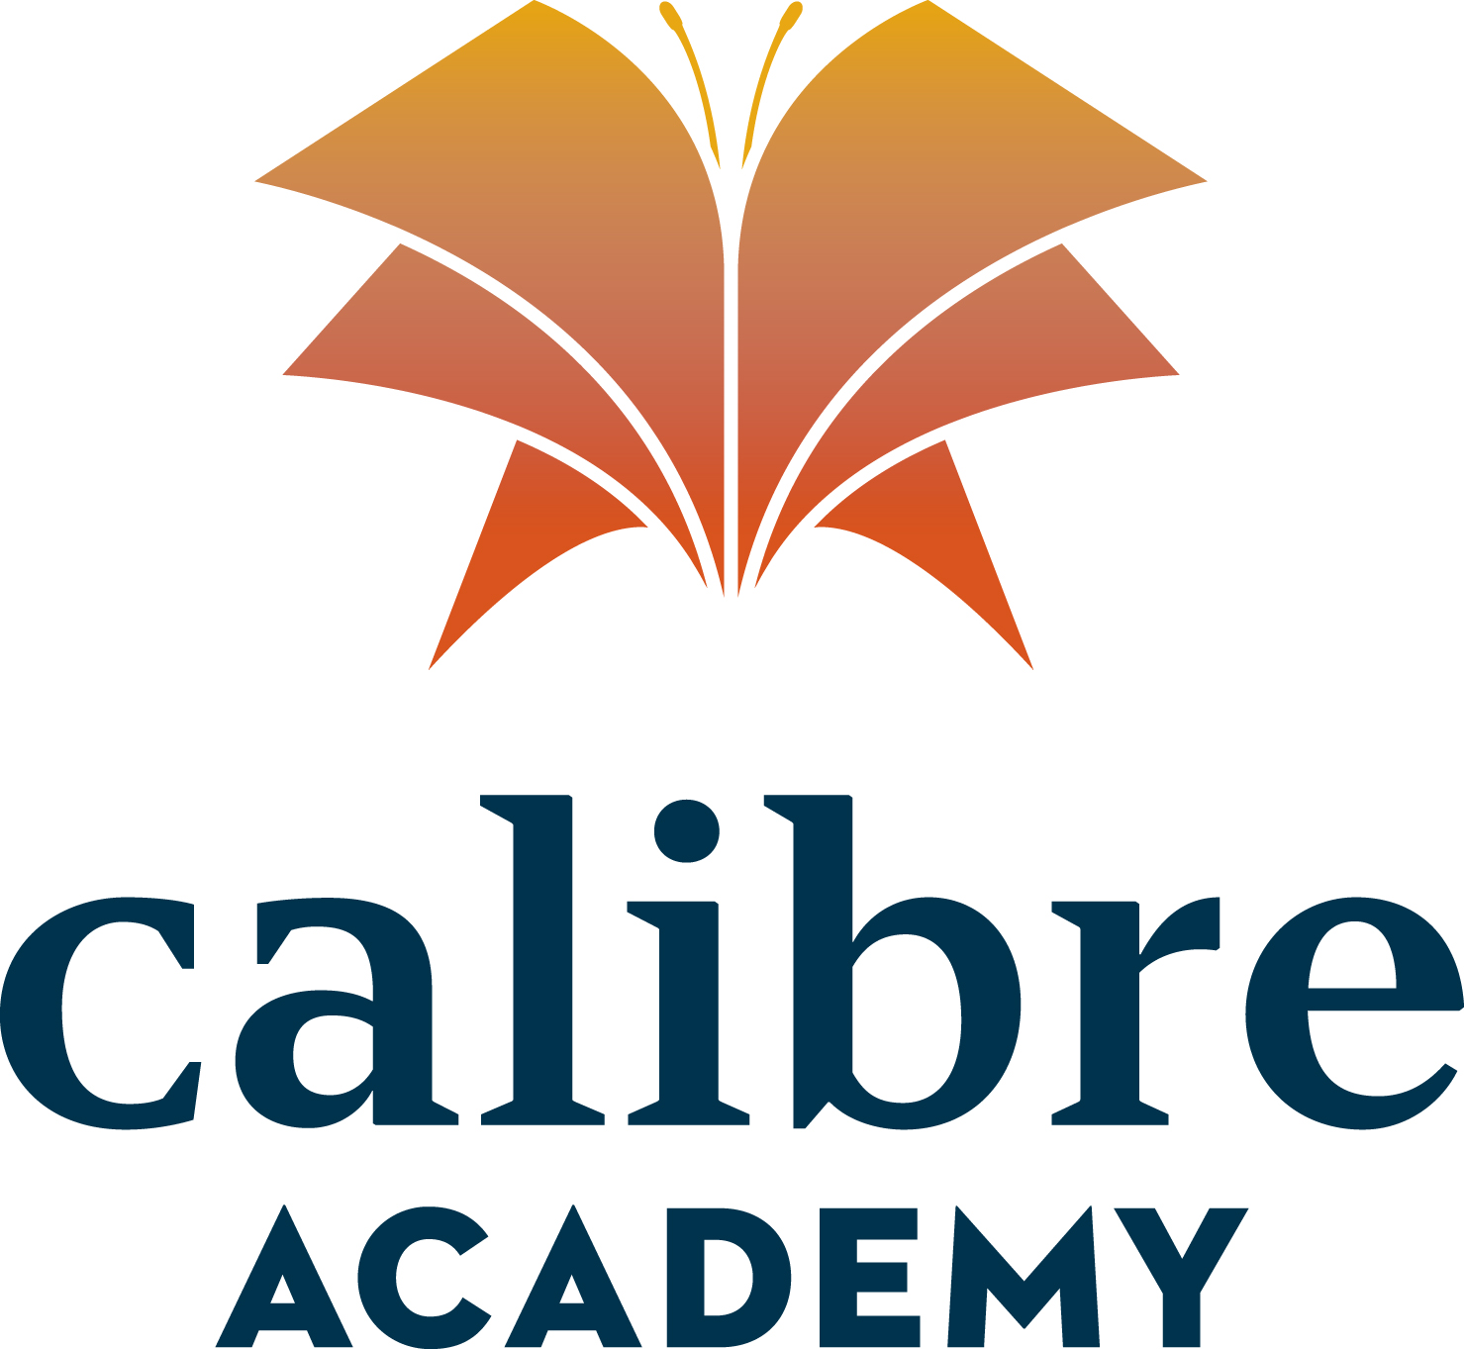

4744 W. Grovers, Glendale, Arizona 85308
PH 602-439-5026 FAX 602-889-0351

Calibre Academy, Inc. Governing Board

Board Meeting Minutes

July 13, 2020
I. Call to order

Kelly Marble called to order the regular meeting of Calibre Academy, Inc. Governing Board at 4:09 p.m. on July 13, 2020 at E-Institute Grover, 4744 W. Grovers Avenue, Glendale, AZ 85308
II. Roll call
Kelly Marble conducted the roll call. The following persons attended the board meeting: Timothy Smith, Danell Stephenson, Kelly Hicks and Michael Mania. Juli Deddo and Shannon Smith were not in attendance.
III. Open Issues
None discussed at this time.
IV. New Business
Approval of Minutes from Last Meeting

Kelly Marble asked the board members if they received a copy of the June 30, 2020 Board Meeting Minutes for their review. All of the board members acknowledged receipt of the minutes.

Danell Stephenson made the motion to approve the minutes.

Kelly Hicks seconded the motion to approve the minutes. Timothy Smith, Danell Stephenson and Kelly Hicks voted in favor of the motion to approve the June 30, 2020 minutes.

Presentation/Approval of the Adopted FY21 Budget

Kelly Marble asked the board members if they received a copy of the Adopted FY21 Budget. All board members acknowledged receipt of the Adopted FY21 Budget. Kelly Marble asked the board members if they had any questions and the board replied that they did not.

Danell Stephen made the motion to approve the Adopted FY21 Budget.

Kelly Hicks seconded the motion.

Timothy Smith, Danell Stephenson and Kelly Hicks voted in favor of the motion to approve the Adopted FY21 Budget.

V. Adjournment

Timothy Smith adjourned the meeting at 4:12 p.m.
Minutes submitted by: Kelly Marble

