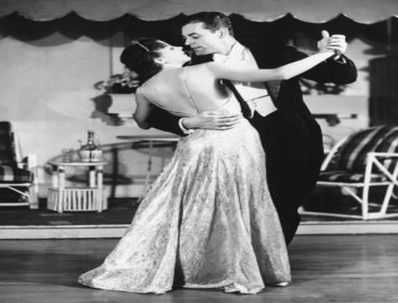

Calibre Academy Father/ Daughter Dance

“Hollywood Glam”

February 10th, 2017 6p – 8p in Cafeteria

Tickets available now!!! Pre-Sale: $12.00 per Father & Daughter/s

Tickets at the Door: $13.00 for Father & Daughter

Unlimited photo booth is $4.00 for the evening.

“We will have a best Hollywood Glam dress contest”

**********PTA Dads are FREE***************

***************************************************************************************

Order: Father/Daughter Ticket @ $12.00 pre-sale ___________

Unlimited Photo Booth @ $4.00 ­­­­­­­­­­­­___________

Total: ____________

Official Use Only:

Payment: ____Square ____Manual C.C. ____Cash ______Check (made out to Mustang PTA)

Card # ____________________________________ EXP________ CCV_______ Zip _________